**Final Report**

POS System for IT Hardware Reseller

CIS 5800 - Professor Schwartz

Group 6 - Ayouba Ba, Jonathan Flugel,   
Tariq Pasha and Nicholas Scala

May 12, 2014

Table of Contents

Introduction and Summary3

I. Phase I

1. Phase I Summary4
2. System Setting4
3. Organizational Structure5
4. Project Environment/System’s History5
5. Existing System Description6
6. Existing System Problems6
7. New System Goals7
8. Data Gathering Plan8
9. Meeting Log9

II. Phase II

1. Phase II Summary10
2. Context Diagrams11
3. Data Flow Diagrams12
4. File Relationship Diagram13
5. Data Dictionary13
6. Domain Class Diagrams14
7. Use Case Diagram15
8. Use Case Specification16
9. Meeting Log26

III. Phase III

1. Phase III Summary27
2. Use Case Specification28
3. Sequence Diagrams39
4. User Interface (UI) Mockups45
5. Meeting Log49

IV. Phase IV

1. Phase IV Executive Summary49
2. Project Summary50
3. Hardware/Software Requirements53
4. Testing/Training Plans55
5. Support Plan56
6. Implementation Plan56
7. Variance from Original Specifications58
8. Proposed Modifications60
9. Meeting Log62

V. Screenshots

1. Phase IV Executive Summary63

VI. Appendix

1. Questionnaires / Data Dictionary

b) PowerPoint Presentations

Introduction and Summary

For this project we took on the role of software consultants and created a software application solution for a hypothetical customer in need of a centralized point of sale and inventory management system. To add to the technical challenge, we proposed a cloud-computing based solution. This required us to learn how to create cloud based applications, as well as it made the project relevant to modern technology trends.

We ultimately created a cloud-based point-of-sale/inventory management solution for an IT hardware reseller, XYZ IT Hardware Solutions. The system is to be used to track inventory and record customer sales. The primary users for the system are sales staff, inventory staff, and mid-level managers. Previously, the system that XYZ IT Hardware Solutions used relied on commercial off-the-shelf software, primarily Microsoft Excel to record transactions and update inventory. This was problematic in that there was no centralized data store. Therefore, the inventory and sales reports were consistently inaccurate and often delayed. The growth of this company has outpaced its previous technology and this, once viable and cost-effective solution, has proved to be insufficient for the growing needs of the firm. Through interviewing key stakeholders and studying their business processes, we gathered the most pertinent requirements to build the best possible solution for our client.

The result was a plan to develop a cloud-based application that integrated both the sales system and the inventory system. By creating a centralized cloud solution for our customer, we were able to eliminate the problems of not having correct sales and inventory reporting. The system also provided the customer with numerous new benefits, such as automatic exporting to Excel, secure login accounts for different user types, and dynamic tracking of inventory and sales. Furthermore, because it is a cloud-based application, all remote and onsite users can utilize the system at any given time while maintaining the integrity of the data.

Application is accessible via this url: http://www.smartscientist.com/CIS5800POScloud/

|  |  |  |
| --- | --- | --- |
| **Username** | **Password** | **Account Type** |
| admin | admin | Administrator |
| j_flugel | flugel | Sales Employee |
| a_ba | ba | Inventory Manager |
| t_pasha | pasha | Sales Manager |
| n_scala | scala | Inventory Employee |

Phase I - Problem Definition

**A. Summary:**

We are IT software consultants working on a cloud-based point-of-sale/inventory management solution for an IT hardware reseller. The system is to be used to track inventory and record sales. The primary users for the system are sales staff, inventory staff, and mid-level managers. Currently the system that XYZ IT Hardware Solutions uses relies on commercial off-the-shelf software, primarily Microsoft Excel to record transactions and update inventory. However, the growth of this company has outpaced its current technology and this once viable and cost-effective solution has proved to be insufficient for the growing needs of the firm. Through interviewing key stakeholders and studying their business processes, we hope to gather the correct requirements to build the best possible solution for our client.

**B. System Setting:**

**Company:**

*XYZ IT Hardware Solutions*

XYZ’s customers are typically small to mid-size businesses operating in diverse environments from retail fronts to office environments with up to 2,000 employees. Their services include hardware consultations, installations, and service support. Their products include desktop computers, portable computers, smartphones, displays, projectors, and servers.

**Industry:**

*General business IT hardware providers*

Most, if not all, small to mid-size businesses depend on their IT infrastructure to conduct business. Regardless of the trade, all of these businesses typically use outside consultants to purchase their IT hardware. XYZ Hardware Solutions is one of those businesses. This is a competitive market where the sustainable competitive advantage comes from timely delivery of IT products and excellent customer service.

**C. Organizational Structure:**

**XYZ IT Hardware Solutions Organizational Chart**

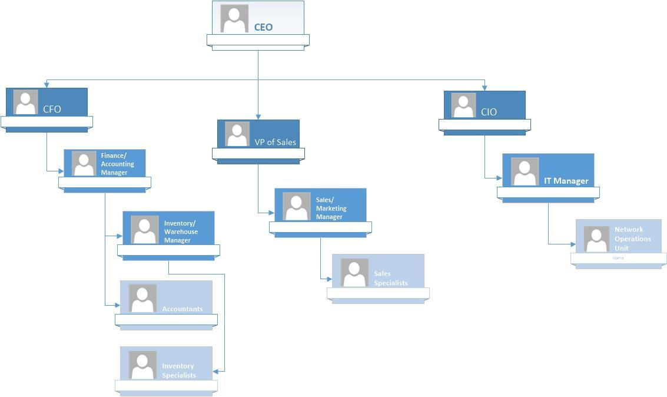

**D. Project Environment/System's History:**

XYZ IT Hardware Solutions entered the market in 2008. This small business started with a point-of-sale system that was rather archaic. Initially sales and inventory transactions were recorded via pen and paper. As the company grew, so did the demands of the technology being used. The company moved over to Microsoft Excel to record both sales and inventory. Although this COTS system is better than the original one because of the accounting functions built into the software, it is inefficient and error prone due to the problems that are listed in Part F. The details of the current system are outline in Part E.

The users of the system and their responsibilities are varied. **Sales employees** have access to record new transactions through the system and retrieve their previous sales history. **Inventory employees** are able to add inventory to the system as well as modify pre-existing inventory item details. **Sales Managers** have access to all sales transaction information as well as specialized reporting tools. Similarly, **Inventory Managers** have access to all inventory information as well as reporting tools. **Upper level management** has complete access over the system.

**E. Existing System Description:**

The current system relies heavily on off-the-shelf business applications such as Microsoft Office. These applications are suitable for small businesses with relatively simply business processes and a small staff. The sales staff are currently creating their own invoices, as well as tracking their own sales in Microsoft Excel. Since there is no standardized system in the organization, each salesperson has a unique Excel method. This is dangerous in that it often leads to miscommunication and confusion. During the sales process the sales staff is currently sending emails and making phone calls to the inventory folks to check for inventory status. This is a messy approach as it is time consuming for all parties involved and there is no standardized form of dealing with inventory inquiries. The processes of handling data are varied from department to department as there is currently no standardized system. The principal outputs are therefore non-standardized, and like the data handling, are widely varied throughout the organization. XYZ has outgrown this simple system.

**F. Existing System Problems (in order of importance):**

1. The current inventory and sales systems are not connected. When a transaction is placed through the POS system for a particular item of a particular quantity, the change in inventory is not automatically realized in the inventory system. Inventory Specialists are in charge of looking at a day’s transactions and making the necessary inventory adjustments. This manual process is error prone and could result in significant problems for customers.

2. The sales staff works remotely, often visiting clients across the country. When a sale is reported by a salesperson, this transaction is not reflected on anyone else’s computer until the end of day. Should a sale be made in one state which wipes out the inventory for a particular item, someone else in a different state could theoretically try to sell the same item on that same day.

3. Since Microsoft Excel is being used by the sales and inventory staff, data such as transaction time, SKU number, and customer information are all inputted manually. This manual entry is error prone and could cause great problems for the organization since data isn’t being captured accurately.

4. The current system does not allow for recording customer product returns in real time. Currently, inventory managers must update the inventory manually and don't know how to handle returns in the electronic inventory system.

5. Currently there is no feature to generate an overall dynamic sales report for the entire organization. For example, things like customer history are not tracked. Therefore the company cannot use data strategically to better position itself and take advantage of things such as determining loyal customers or products that sell better than others.

6. There is no way to record and track purchase orders in the current system.

**Ranking Explanation:** The problems are ranked in order of how each solution will be implemented. The primary functionality is driven by the point of sale and inventory components of the proposed system. These are ranked together as #1 since they are dependent on one another. Problem #2 is the second driver for the new proposed system. While having a non-standardized system has been problematic (problem #1), the inability for sales staff working remotely to monitor inventory data leads to poor customer service and in turn can hurt the company’s profits. Problem #3 works in tandem with #1 and #2. Likewise problem #4 has been causing significant delays in order fulfillment and has been draining staff resources working on inventory returns. While problems #1-#4 and #5 deal directly with the sales process, management is in dire need of better reporting tools and higher resolution sales performance. Currently, manual sales and inventory reports suffer heavy lag times (from query to report) therefore are often inaccurate.

**G. New System Goals:**

1. **Reporting accuracy.** Unite sales and inventory system to allow for more accurate analysis and reporting.

2. **Cost reduction.** Inventory system will update dynamically in real time, this will allow sales staff and inventory staff to make more accurate decisions thereby reducing the costs associated with poorly managed inventory. This will help avoid unnecessary costs associated with overstocking and sudden inventory depletion.

3. **Lead time reduction.** In addition to cost reduction, an improved inventory tracking system will reduce lead times associated with a poor inventory management system. This will help avoid things like overstocking and sudden inventory depletion.

4. **Improved marketing metrics.** Refined sales reports will allow the company to make better marketing decisions on product selection and customer targeting. This will help the company make more informed strategic decisions and better target their marketing dollars. This will help identify trending customer needs.

5. **All the benefits of electronic and integrated purchase orders.** Enable the company to track customer purchase orders which will help improve financial reports as well as streamline inventory management.

6. **Remote access to “Point of Sale” form**. By providing a unified cloud-based point of sale system for the sales staff, each salesperson will be able to create invoices from anywhere with internet access. This will allow them to secure sales during on site client meetings.

**H. Data Gathering Plan:**

**How will the team perform the system's study?**

The best way to perform the system's study is to understand what type of business you’re dealing with, the current software system being used, who will be using the new system and what are their needs for a reliable system. By understanding the client’s needs it will help the analysts better understand what type of system should be developed and the complexity of what they need to build. The key driver in developing a new system is to understand the user requirements. In the case of XYZ IT Hardware Solutions, the business is driven by the sales process. This means that our study will revolve on studying the business processes related to the sales cycle, and how these actions are reflected on the backend (primarily the handling of inventory data).

**Two Questionnaires:**

1. General User Questionnaire given to sales and inventory personnel (See Attached)

2. Management User Questionnaire given to upper-level management (See Attached)

**Sample Interview Questions:**

1. (For sales staff) Please walk us through your point-of-sale process.

2. Identify some advantages and disadvantages that you feel are important in the current system you are working with?

3. What is the hardest challenge working with the old system?

4. What are your top three requirements that you would like to see in the new system?

**Other Data Sources:**

Other than surveys and questionnaires there are a couple of other techniques that can be employed to gather requirements and map the current state. We can conduct brainstorming sessions with our client asking open ended questions geared toward finding out pain points of the current system and possible solutions. We can also observe use of the current system to identify user interactions and necessities.

**I. Meeting Log:**

**Internal Meeting Log:**

2/10 - Group met in Baruch cafeteria and began to brainstorm the primary functions of our system. We decided on building a POS system and determined that our client will be an IT hardware reseller. We briefly discussed possible answers to each parts of Phase I.

2/17 - Group met via Google Drive chat and collaborated on fleshing out the answers to all of the questions given on the syllabus.

2/18 - Group met via Google Drive chat to create the presentation and divide the parts of who is presenting what particular section.

Phase II– System Representation/Design

**A. Summary:**

We are IT software consultants working on a cloud-based point-of-sale/inventory management solution for an IT hardware reseller. The system is to be used to track inventory and record sales. The primary users for the system are sales staff, inventory staff, and mid-level managers. Currently the system that XYZ IT Hardware Solutions uses relies on commercial off-the-shelf software, primarily Microsoft Excel to record transactions and update inventory. However, the growth of this company has outpaced its current technology and this once viable and cost-effective solution has proved to be insufficient for the growing needs of the firm. Through interviewing key stakeholders and studying their business processes, we hope to gather the correct requirements to build the best possible solution for our client.

During Phase II of this project we have focused on the Design documentation for the proposed system. The primary users and uses of the system have been documented via a Use Case Diagram with accompanying Use Case specifications. The data work required for the system has been documented via Data Flow Diagrams, Entity Relationship Diagrams, and a Data Dictionary. A Domain Class Diagram has been created for the purpose of identifying classes that will be created when programming the final product.

**B. Context Diagrams**

**Proposed System Level 0 Diagram:**



**Proposed System Level 1 Diagram:**



**C. Data Flow Diagrams**

**Proposed System Level 0 Diagram:**



**Proposed System Level 1 and Level 2 Diagram:**



**D. File Relationship Diagram:**

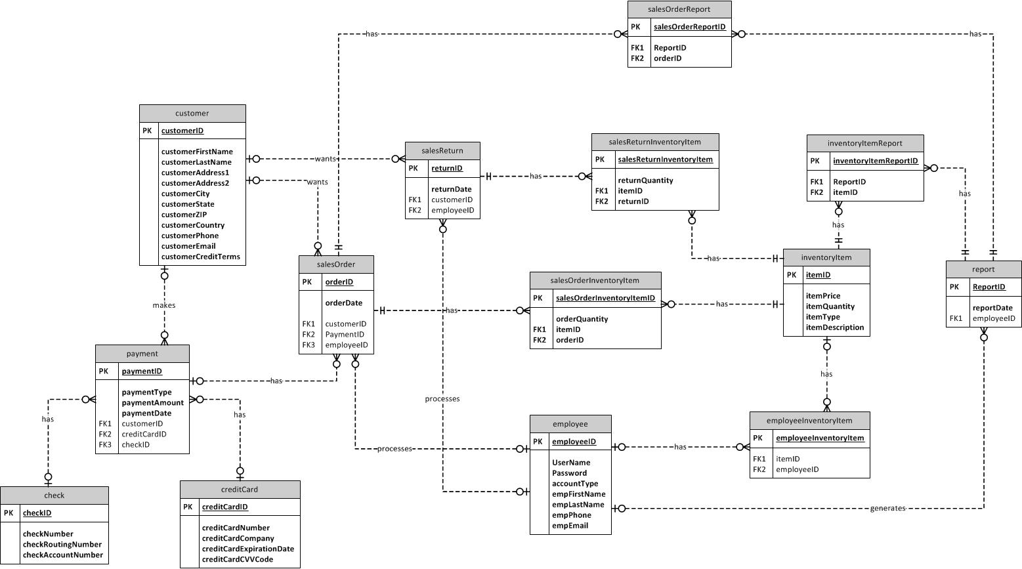

**E. Data Dictionary:**

See attached document

**F. Domain Class Diagram**

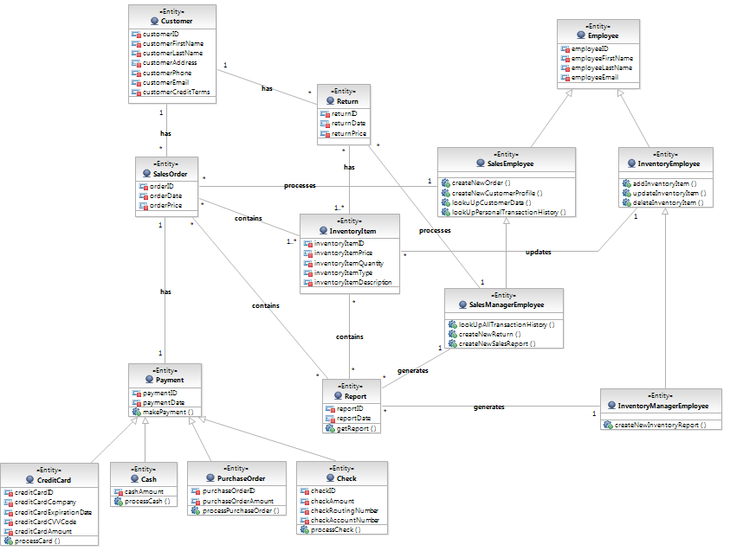

**G. Use Case Diagram**

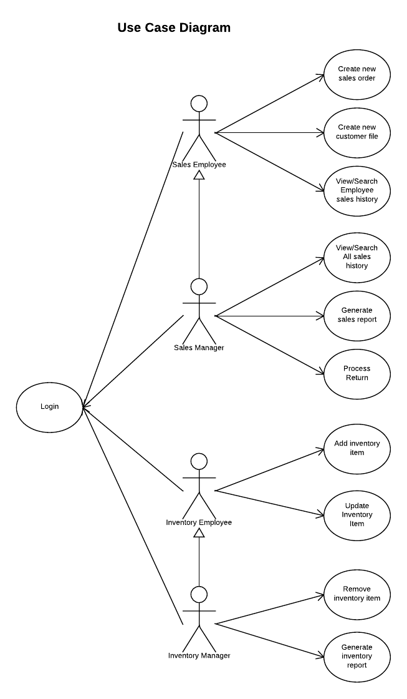

**H. Use Case Specifications**

1. **Create New Sales Order**

|  |
| --- |
| **Use case:** Create New Sales Order |
| **ID:** 001 |
| **Brief Description:** This use case describes the process to follow when a sales employee/manager generates a new sales order on behalf of the customer. |
| **Primary actors:** Sales Employee, Sales Manager |
| **Secondary actors:** n/a |
| **Pre-conditions:** User is logged in |
| **Main flow:** |
|  |
| **Post-conditions: n/a** |
| **Alternate flows:**   * Item not available * Customer account assigned to different sales person |

1. **Create New Customer File**

|  |
| --- |
| **Use case:** Create New Customer File |
| **ID:** 002 |
| **Brief Description:** This use case describes the process to follow when a sales employee/manager generates a new customer profile. This is done to track possible future clients and includes the customers important information such as name, address, email, phone number etc. |
| **Primary actors:** Sales Employee, Sales Manager |
| **Secondary actors:** n/a |
| **Pre-conditions:** User is logged in |
| **Main flow:** |
|  |
| **Post-conditions:** n/a |
| **Alternate flows:** n/a |

1. **View/Search Employee Sales history**

|  |
| --- |
| **Use case:** View/Search Employee Sales history |
| **ID:** 003 |
| **Brief Description:** This use case describes the process to follow when a sales employee/manager wishes to view his/her personal transaction history. This list of transactions can be searched via a number of ways such as by date, customer, etc. |
| **Primary actors:** Sales Employee, Sales Manager |
| **Secondary actors:** n/a |
| **Pre-conditions:** User is logged in |
| **Main flow:** |
|  |
| **Post-conditions:** n/a |
| **Alternate flows:** n/a |

1. **View/Search All Sales History**

|  |
| --- |
| **Use case:** View/Search All Sales History |
| **ID:** 004 |
| **Brief Description:** This use case describes the process to follow when a sales manager wishes to view the sales history of all transactions. This list of transactions can be searched via a number of ways such as by employee, date, customer, etc. |
| **Primary actors:** Sales Manager |
| **Secondary actors:** n/a |
| **Pre-conditions:** User is logged in |
| **Main flow:** |
|  |
| **Post-conditions:** n/a |
| **Alternate flows:** n/a |

1. **Generate Sales Report**

|  |
| --- |
| **Use case:** Generate Sales Report |
| **ID:** 005 |
| **Brief Description:** This use case describes the process to follow when a sales manager wishes to generate a sales report. Before generating the report the manager can specify the contents (e.g. specific time period, employee, product, etc.). This report will be a downloadable .csv file for manipulation in Excel. |
| **Primary actors:** Sales Manager |
| **Secondary actors:** n/a |
| **Pre-conditions:** User is logged in |
| **Main flow:** |
|  |
| **Post-conditions:** n/a |
| **Alternate flows:** n/a |

1. **Process Return**

|  |
| --- |
| **Use case:** Process Return |
| **ID:** 006 |
| **Brief Description:** This use case describes the process to follow when a sales manager wishes to process a return on behalf of the customer. |
| **Primary actors:** Sales Employee |
| **Secondary actors:** n/a |
| **Pre-conditions:** User is logged in |
| **Main flow:** |
|  |
| **Post-conditions:** n/a |
| **Alternate flows:**   * Item was not purchased by customer |

1. **Add Inventory Item**

|  |
| --- |
| **Use case:** Add Inventory Item |
| **ID:** 007 |
| **Brief Description:** This use case describes the process to follow when an inventory employee/manager wishes to add a new inventory item to the inventory list. |
| **Primary actors:** Inventory Employee, Inventory Manager |
| **Secondary actors:** n/a |
| **Pre-conditions:** User is logged in |
| **Main flow:** |
|  |
| **Post-conditions:** n/a |
| **Alternate flows:** n/a |

1. **Update Inventory Item**

|  |
| --- |
| **Use case:** Update Inventory Item |
| **ID:** 008 |
| **Brief Description:** This use case describes the process to follow when an inventory employee/manager wishes to update the details of an inventory item. This can include its description, quantity, etc. |
| **Primary actors:** Inventory Employee, Inventory Manager |
| **Secondary actors:** n/a |
| **Pre-conditions:** User is logged in |
| **Main flow:** |
|  |
| **Post-conditions:** n/a |
| **Alternate flows:** n/a |

1. **Remove Inventory Item**

|  |
| --- |
| **Use case:** Remove Inventory Item |
| **ID:** 009 |
| **Brief Description:** This use case describes the process to follow when an inventory manager wishes to remove an item from inventory. |
| **Primary actors:** Inventory Manager |
| **Secondary actors:** n/a |
| **Pre-conditions:** User is logged in |
| **Main flow:** |
|  |
| **Post-conditions:** n/a |
| **Alternate flows:** n/a |

1. **Generate Inventory Report**

|  |
| --- |
| **Use case:** Generate Inventory Report |
| **ID:** 010 |
| **Brief Description:** This use case describes the process to follow when an inventory manger wishes to generate an inventory report. Before generating the report the manager can specify the contents (e.g. specific time period, inventory item, etc.). This report will be a downloadable .csv file for manipulation in Excel. This inventory report contains a list of items that are low in quantity as well as some inventory trends. |
| **Primary actors:** Inventory Manager |
| **Secondary actors:** n/a |
| **Pre-conditions:** User is logged in |
| **Main flow:** |
|  |
| **Post-conditions:** n/a |
| **Alternate flows:** n/a |

**I. Meeting Log**

**Internal Meeting Log:**

3/3 – Group met in Baruch cafeteria to concretely define functionality, user roles, and basic UI elements.

March – Group continually assigned tasks and collaborated on them via virtual technologies such Lucid Chart, Dropbox, and Google Drive.

3/24 – Group met in Baruch cafeteria and began to organize what has been created so far and what still needs to be done. Further meeting dates were established to start the coding of the application, Phase II documentation was reviewed and revised, and the Phase II presentation was discussed.

3/29 – Group met in Baruch library. The presentation for Phase II was created. The Entity Relationship Diagram was revised. The Microsoft Access database was created.

3/30 – Group met in Baruch cafeteria. Beginning programming was undertaken and the Phase II presentation was rehearsed.

Phase III – System Design Prototype

**A. Summary:**

We are IT software consultants working on a cloud-based point-of-sale/inventory management solution for an IT hardware reseller. The system is to be used to track inventory and record sales. The primary users for the system are sales staff, inventory staff, and mid-level managers. Currently the system that XYZ IT Hardware Solutions uses relies on commercial off-the-shelf software, primarily Microsoft Excel to record transactions and update inventory. However, the growth of this company has outpaced its current technology and this once viable and cost-effective solution has proved to be insufficient for the growing needs of the firm. Through interviewing key stakeholders and studying their business processes, we hope to gather the correct requirements to build the best possible solution for our client.

During Phase III of this project we have focused on designing and prototyping the point of sale system.

**B. Use Case Specification**

1. **Create New Sales Order**

|  |
| --- |
| **Use case:** Create New Sales Order |
| **ID:** 001 |
| **Brief Description:** This use case describes the process to follow when a sales employee/manager generates a new sales order on behalf of the customer. |
| **Primary actors:** Sales Employee, Sales Manager |
| **Secondary actors:** n/a |
| **Pre-conditions:** User is logged in |
| **Main flow:** |
|  |
| **Post-conditions: n/a** |
| **Alternate flows:**   * Item not available * Customer account assigned to different sales person |

1. **Create New Customer File**

|  |
| --- |
| **Use case:** Create New Customer File |
| **ID:** 002 |
| **Brief Description:** This use case describes the process to follow when a sales employee/manager generates a new customer profile. This is done to track possible future clients and includes the customers important information such as name, address, email, phone number etc. |
| **Primary actors:** Sales Employee, Sales Manager |
| **Secondary actors:** n/a |
| **Pre-conditions:** User is logged in |
| **Main flow:** |
|  |
| **Post-conditions:** n/a |
| **Alternate flows:** n/a |

1. **View/Search Employee Sales history**

|  |
| --- |
| **Use case:** View/Search Employee Sales history |
| **ID:** 003 |
| **Brief Description:** This use case describes the process to follow when a sales employee/manager wishes to view his/her personal transaction history. This list of transactions can be searched via a number of ways such as by date, customer, etc. |
| **Primary actors:** Sales Employee, Sales Manager |
| **Secondary actors:** n/a |
| **Pre-conditions:** User is logged in |
| **Main flow:** |
|  |
| **Post-conditions:** n/a |
| **Alternate flows:** n/a |

1. **View/Search All Sales History**

|  |
| --- |
| **Use case:** View/Search All Sales History |
| **ID:** 004 |
| **Brief Description:** This use case describes the process to follow when a sales manager wishes to view the sales history of all transactions. This list of transactions can be searched via a number of ways such as by employee, date, customer, etc. |
| **Primary actors:** Sales Manager |
| **Secondary actors:** n/a |
| **Pre-conditions:** User is logged in |
| **Main flow:** |
|  |
| **Post-conditions:** n/a |
| **Alternate flows:** n/a |

1. **Generate Sales Report**

|  |
| --- |
| **Use case:** Generate Sales Report |
| **ID:** 005 |
| **Brief Description:** This use case describes the process to follow when a sales manager wishes to generate a sales report. Before generating the report the manager can specify the contents (e.g. specific time period, employee, product, etc.). This report will be a downloadable .csv file for manipulation in Excel. |
| **Primary actors:** Sales Manager |
| **Secondary actors:** n/a |
| **Pre-conditions:** User is logged in |
| **Main flow:** |
|  |
| **Post-conditions:** n/a |
| **Alternate flows:** n/a |

1. **Process Return**

|  |
| --- |
| **Use case:** Process Return |
| **ID:** 006 |
| **Brief Description:** This use case describes the process to follow when a sales manager wishes to process a return on behalf of the customer. |
| **Primary actors:** Sales Employee |
| **Secondary actors:** n/a |
| **Pre-conditions:** User is logged in |
| **Main flow:** |
|  |
| **Post-conditions:** n/a |
| **Alternate flows:**   * Item was not purchased by customer |

1. **Add Inventory Item**

|  |
| --- |
| **Use case:** Add Inventory Item |
| **ID:** 007 |
| **Brief Description:** This use case describes the process to follow when an inventory employee/manager wishes to add a new inventory item to the inventory list. |
| **Primary actors:** Inventory Employee, Inventory Manager |
| **Secondary actors:** n/a |
| **Pre-conditions:** User is logged in |
| **Main flow:** |
|  |
| **Post-conditions:** n/a |
| **Alternate flows:** n/a |

1. **Update Inventory Item**

|  |
| --- |
| **Use case:** Update Inventory Item |
| **ID:** 008 |
| **Brief Description:** This use case describes the process to follow when an inventory employee/manager wishes to update the details of an inventory item. This can include its description, quantity, etc. |
| **Primary actors:** Inventory Employee, Inventory Manager |
| **Secondary actors:** n/a |
| **Pre-conditions:** User is logged in |
| **Main flow:** |
|  |
| **Post-conditions:** n/a |
| **Alternate flows:** n/a |

1. **Remove Inventory Item**

|  |
| --- |
| **Use case:** Remove Inventory Item |
| **ID:** 009 |
| **Brief Description:** This use case describes the process to follow when an inventory manager wishes to remove an item from inventory. |
| **Primary actors:** Inventory Manager |
| **Secondary actors:** n/a |
| **Pre-conditions:** User is logged in |
| **Main flow:** |
|  |
| **Post-conditions:** n/a |
| **Alternate flows:** n/a |

1. **Generate Inventory Report**

|  |
| --- |
| **Use case:** Generate Inventory Report |
| **ID:** 010 |
| **Brief Description:** This use case describes the process to follow when an inventory manger wishes to generate an inventory report. Before generating the report the manager can specify the contents (e.g. specific time period, inventory item, etc.). This report will be a downloadable .csv file for manipulation in Excel. This inventory report contains a list of items that are low in quantity as well as some inventory trends. |
| **Primary actors:** Inventory Manager |
| **Secondary actors:** n/a |
| **Pre-conditions:** User is logged in |
| **Main flow:** |
|  |
| **Post-conditions:** n/a |
| **Alternate flows:** n/a |

**C. Sequence Diagrams**

1. **Create New Sales Order**



1. **Create New Customer Profile**



1. **View/Search Employee Sales history**



1. **Generate Sales Report**



1. **Process Return**



1. **Add Inventory Item**



**D. UI Mockups**

Sales Employee UI

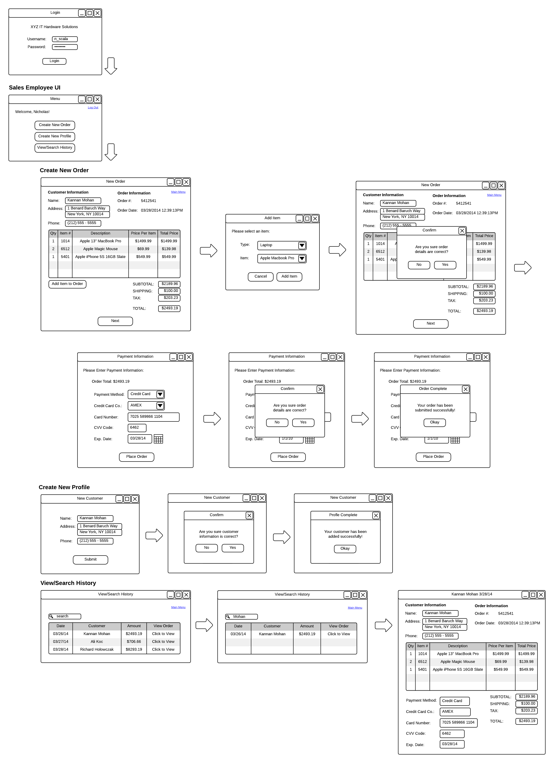

Sales Manager UI

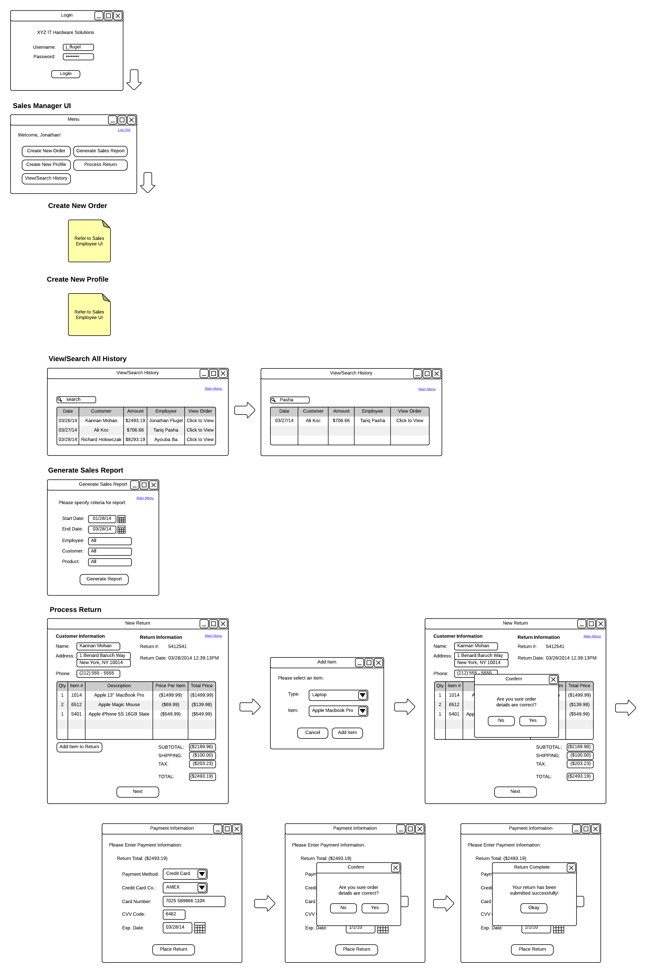

**Inventory Employee UI**

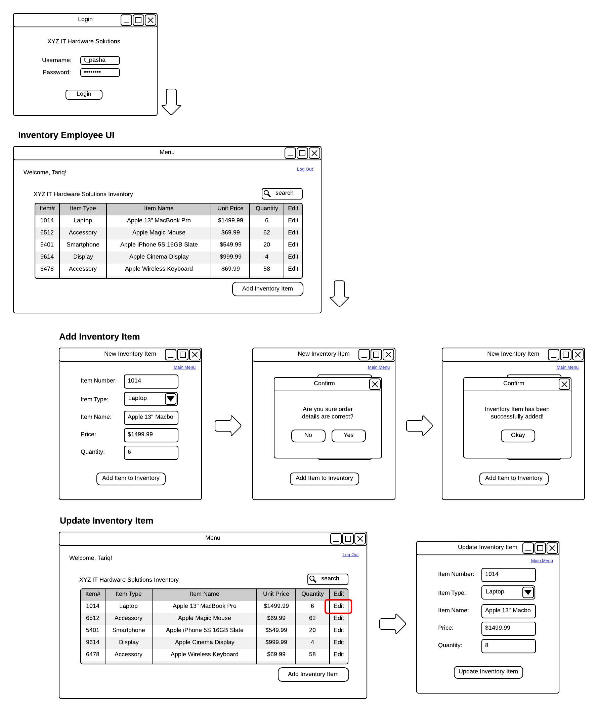

Inventory Manager UI

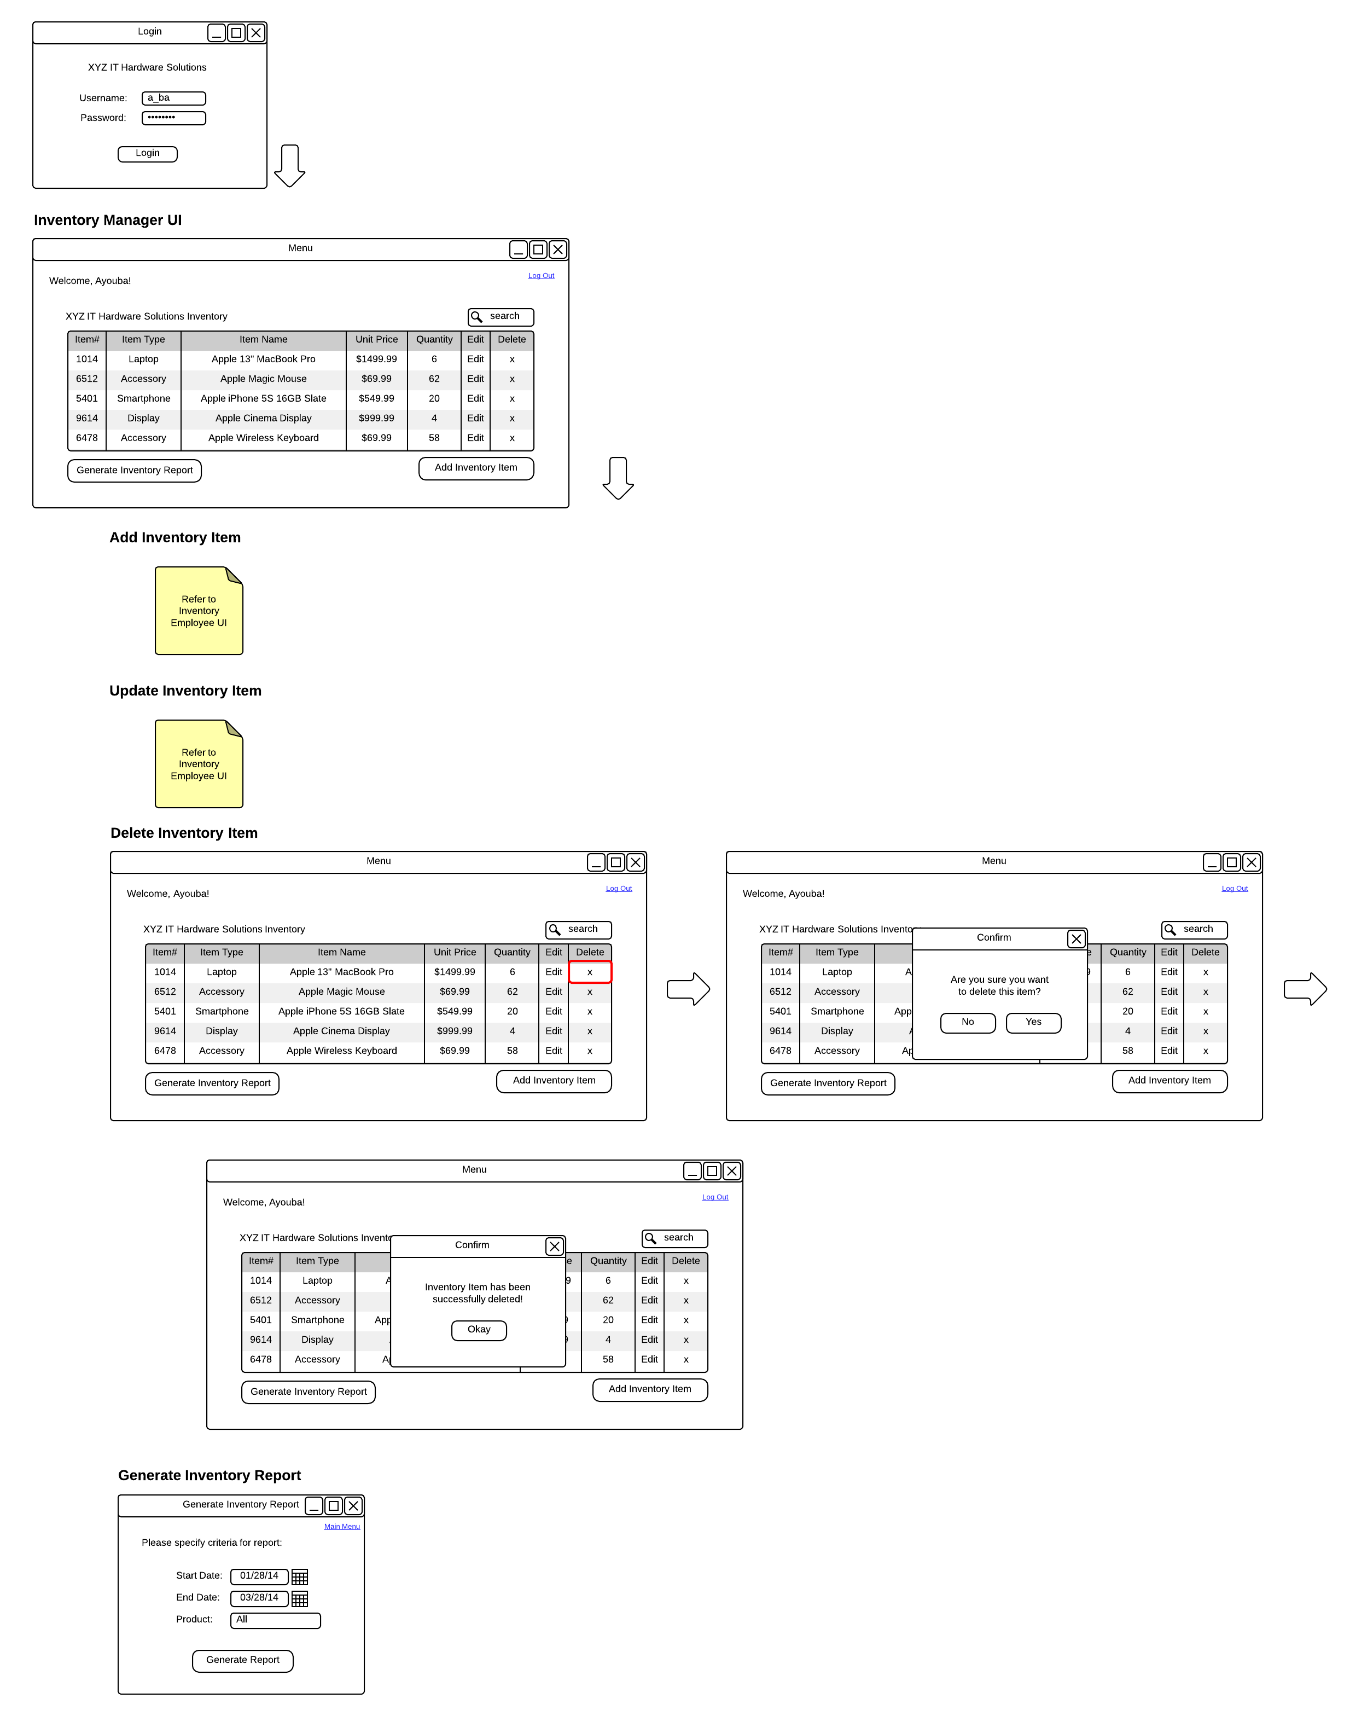

**E. Meeting Log**

**Internal Meeting Log:**

3/29 – Group met in Baruch library. The presentation for Phase II was created. The Entity Relationship Diagram was revised. The Microsoft Access database was created.

3/30 – Group met in Baruch cafeteria. Beginning programming was undertaken and the Phase II presentation was rehearsed.

4/5 – Group met in Baruch computer lab to start coding the application.

4/12 – Group met in Baruch cafeteria to continue coding the application.

4/21 – Group met in Baruch library to continue coding the application and create sequence diagrams

Phase IV – System Implementation

**A. Executive Summary:**

We are IT software consultants working on a cloud-based point-of-sale/inventory management solution for an IT hardware reseller, XYZ IT Hardware Solutions. The system is to be used to track inventory and record customer sales. The primary users for the system are sales staff, inventory staff, and mid-level managers. Previously, the system that XYZ IT Hardware Solutions used relied on commercial off-the-shelf software, primarily Microsoft Excel to record transactions and update inventory. This was problematic in that there was no centralized data store. Therefore, the inventory and sales reports were consistently inaccurate and often delayed. The growth of this company has outpaced its previous technology and this, once viable and cost-effective solution, has proved to be insufficient for the growing needs of the firm. Through interviewing key stakeholders and studying their business processes, we gathered the most pertinent requirements to build the best possible solution for our client.

The result was a plan to develop a cloud-based application that integrated both the sales system and the inventory system. By creating a centralized cloud solution for our customer, we were able to eliminate the problems of not having correct sales and inventory reporting. The system also provided the customer with numerous new benefits, such as automatic exporting to Excel, secure login accounts for different user types, and dynamic tracking of inventory and sales. Furthermore, because it is a cloud-based application, all remote and onsite users can utilize the system at any given time while maintaining the integrity of the data.

**B. Project Summary**

The primary problem our customer faced was the lack of a centralized system to handle its sales operations. As the company grew, so did its sales and inventory staff. Before our application, each employee kept track of their activity in their own way utilizing applications like Microsoft Excel and Word. This created a serious problem in that the sales and inventory reports were often inaccurate. The company was hesitant to purchase commercial off the shelf software since most of what was available in the market was meant for a centralized server within the organization’s network. The customer wanted an application that was accessible via the Internet using a web browser. The reasoning behind this is that most of the sales staff works remotely, often finalizing sales at the customer’s place of business.

We developed a cloud-based point of sales and inventory system that is specifically tailored to our customer. The application can be accessed with a basic Internet connection and a web browser. Since it is an Internet application, we implemented a secured login system. Once the user’s username and password are validated, our system then checks the user type to see if they are a sales manager, inventory manager, sales staff, or inventory staff. Depending on the user’s user type, a customized menu will then appear after login authentication. We created separate menus for each user type and the content of each menu will differ. The main exception is the “administrator” user type, which will have the option of accessing every menu and function in the system.

**User Type and Permissions**

**Sales Employee**

While we treated all user types with high priority, the core user of the system are sales folks. The reasoning behind this is because the sales process is, not only the key driver in the system, but also features the most functions of any other user type. The only exception to this description are sales managers, but the sales manager user type inherits the capabilities of the sales user, so we will stick with this description.

When sales staff first log on to the system, they will see a menu that will allow them to (1) create a new sales order, (2) view their sales history, (3) create a new customer profile, or (4) view customer list. The most important function here is the ability to create a new sales order. The “new sales order” form allows the sales user to lookup a customer profile, to compile a list of products and their quantities, and to enter in payment information. The new sales order form allows the user to enter a quantity, select a product type (of which the product type selection is used to query the database for products in that category), and select a specific product within the category. The user can do this for multiple products and then select a shipping category. The user is also given a drop down menu to select a specified state in order to calculate sales tax. Once the user clicks on the “calculate” button, all of the products are summed, added to shipping, and then tax is calculated. The user is then given the ability to confirm all the entries before committing the sales order to the database.

**Sales Manager**

The sales manager is able to do everything that the sales staff is able to do (described above). In addition, the sales manager can view all sales history, for every sales staff member. The sales manager can also export and download all the sales data to Excel for further analysis. In the future, we also intend on creating the ability to return specific products within a previous sales order.

**Inventory Employee**

The inventory employee’s primary capability is the ability to add and/or edit items in the inventory list. Since this gives entry-level employees the ability to write and modify the inventory database tables, this account is highly restricted only to these functions. When creating a new inventory item to add to the database, the user is able to select the item type, item name, price and quantity received. In regards to editing existing inventory items, the inventory employee user type is only able to modify quantities.

**Inventory Manager**

The inventory manager has far more access to the inventory database than the inventory employee. Most notably, the inventory manager can modify more than just the quantity of an item record. The inventory manager is able to modify product types and descriptions of existing inventory records in the database. Lastly, another critical difference between inventory user types is that the manager is able to export and download a list of inventory in Excel format.

**Technologies Utilized**

In our approach to create a point of a sales system for a customer we wanted to leverage recent matured technologies. The technologies including cloud computing, ASP.NET 4.5, Twitter Bootstrap, Microsoft LINQ, SQL, Font Awesome, HTML-5, CSS3, and Internet Explorer Developer Tools, Microsoft Visual Studio 2013. We’ve outlined a list of the technologies utilized along with our justification of incorporation.

**Cloud Computing**

Cloud computing allows our customer to have multiple users (employees, most notably sales staff). Furthermore, this helps us to achieve the goal of having a centralized system so that all data in the system is dynamically updated in real-time, thereby dramatically increasing the accuracy of our customer’s reports.

**ASP.NET 4.5**

The ASP.NET (Active Server Pages) framework from Microsoft allowed us to leverage our programming abilities in C# to write server-side applications. This framework is also what empowers our system to create dynamically generated web pages, which are essential in the key components of our system, such as the sales order form, and all the various reporting functions.

**Twitter Bootstrap and CSS3**

Bootstrap provided us with a set of tools to control our CSS design files. This was essential for creating a cohesive user interface and this technology was responsible for improving our program’s typography, forms, buttons and navigation. CSS (cascading style sheets) worked in conjunction with Bootstrap and it allowed us to better control our application’s overall design elements. The main premise behind this technology is that all the design elements are coded into design files, allowing our HTML code pages to focus on structure, and our code-behind-files to focus on server side scripting. To validate all of the CSS code we utilized Microsoft Internet Explorer’s Developer Tools.

**Language Integrated Query (LINQ)**

This is part of Microsoft’s .NET framework that allowed us to add native data querying capabilities via ASP. By definition, “LINQ extends the language (ASP) by the addition of query expressions, which are akin to SQL statements, and can be used to conveniently extract and process data”, in our case, from an SQL relational database (Wikipedia). This technology significantly reduced our database development time because of its streamlined approach at creating query statements. Furthermore, this added a layer of stability to our data handling since it is tightly integrated with the other Microsoft technologies we utilized (ASP.NET, Internet Explorer Developer Tools, etc.).

**C. Hardware/Software Requirements**

**Server Side**

We recommend that our customer not invest in a hardware server solution. Instead, we recommend utilizing a cloud-computing platform such as Microsoft Azure or Amazon Web Services. These services require little to no up front investment, and only charge fees based on usage. Furthermore, these services are dynamic in nature so our customer would not have to be concerned about investments in future capacity. Due to the nature of our customer’s activities, we anticipate modest bandwidth utilization; so all costs would be minimal. By utilizing a cloud-computing platform service provider, the responsibility of the infrastructure (such as hardware and server software licenses) is shifted to the providers. This helps to mitigate risks (such as hardware failure, or license maintenance authentication), and ultimately lowers costs. Of the two services mentioned, we would recommend Microsoft Azure. The reason for this is that the application was built utilizing Microsoft tools and technologies. Thus, integration is tighter, deployments are easier, and we would have access to

**Bandwidth Breakdown (Fig. 1)**

|  |  |  |  |  |
| --- | --- | --- | --- | --- |
| **Number of Users** | **Bandwidth (GB) per User** | **Cost Per 1GB of Bandwidth** | **Monthly Cost (all users)** | **Annual Cost (all users)** |
| 2000 | 2 | $0.12 | $239.40 | $2,872.80 |

**Annual Cloud Computing Cost Breakdown (Fig. 2)**

|  |  |
| --- | --- |
| **Bandwidth** | $2,872.80 |
| **SQL Database (10GB)** | $551.52 |
| **Cloud Support** | $3,600.00 |

Sources: Microsoft Azure (azure.microsoft.com)

For our usage and storage estimate, Tariq Pasha conducted an interview with the system administrator at his current place of work (United Nations) to obtain estimates on bandwidth usage and database size.

**User Side**

We recommend that our customer deploy Microsoft Surface 2 Tablets with AT&T LTE service and keyboard case cover. Our justification for this is as follows: The Surface 2 tablet is designed to be ultra portable and can function as both a table and a laptop computer. Future improvements on the application could take advantage of the touch screen functionality of the Surface 2. The LTE service would also provide the users, most of which are travelling to customer locations and work remotely, with redundancy for accessing the Internet. This means that the end user would not have to depend on Wi-Fi service being available on work sites. The cost for the Surface 2 with LTE is $679 or $499 with 2-year contract. The AT&T wireless LTE service is $30 per month, per machine. The keyboard case is $129. We listed the advertised retail prices for these devices and services. We believe that a deal can be negotiated with a Microsoft reseller and AT&T to obtain a better price for these items and services. The information presented in figure 3 is the worst-case/most expensive scenario based on published figures.

**First Year User Hardware Cost (Fig. 3)**

|  |  |  |  |  |  |
| --- | --- | --- | --- | --- | --- |
| **Number of Users** | **Surface 2 Tablet w/ LTE** | **AT&T LTE Service (Annual)** | **Surface 2 Keyboard Case** | **First Year Cost Per User** | **Total First Year Cost Based on 2000 Users** |
| 2000 | $499.00 | $360.00 | $129.00 | $988.00 | $1,976,000.00 |

**D. Testing and Training Plan**

**Testing Plan**

We will propose to the client a 6-month allotment once the initial program is near delivery. Our defining criteria for the beginning of this time allotment are that all primary functions (as per the requirements) are functional. In the beginning of this phase we intend on deploying a beta version of the application to a small and carefully selected group of beta testers within the organization. We would like to have 3 beta testers for each user type (for a total of 12 beta testers). The beta testing period will be 3 weeks. After the three-week period, we will access the feedback from our testers (in the form of interviews, questionnaires, and narratives). We’ve created a wide span of time so that we have the ability to carefully study any and all feedback. We will re-work whatever necessary to improve and enhance the end user experience and to make sure we are satisfying critical key requirements. After this period (on approximately month 2 of our testing phase) we will re-deploy the updated version of the program. Again, after 3 weeks, we will collect any new feedback from the beta testers. We will then decide at this stage if another round of beta testing is required. With the 6-month total allotment, this leaves us approximately 3 months to repeat the beta test cycle. If another round of testing is not required, we will use the remaining 3 months to create documentation and to prepare for deployment to all users. The customer’s system administrator and executive board will ultimately approve all beta testing and revisions. These particular stakeholders will also be the ones to give the green light for deployment to all users.

**Training Plan**

Since the goal of this application is to centralize and standardized the sales and inventory system, we propose a robust, and cohesive training plan to all employees of XYZ Hardware Solutions that will be utilizing the system.

The training will be conducted in small groups of no more than 20 users at a time. All four of us will begin to lead the courses, and we will query the trainees after the course to see if they would like to volunteer for additional training, so that they could become trainers themselves. We will also ask our beta testers to see if they are interested in becoming trainers. We will work with XYZ Hardware Solutions to create an incentive system for their employees to become trainers. If the testing plan is a success, we will begin training 3 months before company-wide deployment. We will also ask for feedback after the training in the form of email questionnaires.

**E. Support Plan**

We will offer XYZ Hardware Solutions support as part of the initial contract for 6 months. We will be offering XYZ Hardware Solutions several contract options if they would like. We will offer 6-month support contracts in the form of retainers. We would require a monthly retainer of $4000. Support will be charged at $25 per hour, with a $25 minimum charge per incident. The retainer would follow a hypothetical 40-hour per week entry level support staff. At the end of the contract period, we would charge a $1000 contract maintenance fee. Any amount of the retainer not charged, would be refunded to the client or rolled over into another contract. The customer would make this decision at the end of each contract term.

Support provided to the customer will be available Monday through Friday during business hours (9am to 5pm). The customer will be able to reach us for support via a telephone hotline and/or via email. If necessary, arrangements for on-site visits will be made.

**F. Implementation Plan**

There are various paths to implementation, each with its own set of trade offs. For this reason, we are presenting to our client 3 different implementation options. Each option is designed with a 3-month time frame goal. We will conclude this section with our recommendation.

Option 1 – Company Wide – Immediate Implementation

Option 2 – Company Wide - Gradual Implementation

Option 3 – Gradual Implementation Based on Function

**Option 1 – Company Wide – Immediate Implementation**

With this option, every user in every functional department of the company will go “live” with the new system. This implementation is the most intensive of all the options. We have created 3 implementation phases to help with the transition.

Phase 1 – Training and Software Deployment – 1st and 2nd Month

While in this phase, users will continue to use the previous system to fulfill the business functions. Every user will receive their own unique username and password, but the database will be a “dummy” database so that users can experiment and learn the system. Each user will be scheduled for training during this phase. The goal is to complete training by the middle or end of the 2nd month.

Phase 2 – Buffer Phase - 2nd Month

This phase is designed to tie up any lose ends from Phase 1. The database will still be a “dummy” database. During this phase, any users with questions or difficulties will be tended to. If necessary, we can perform fixes for minor bugs.

Phase 3 – Roll Out – 3rd Month

At the start of Phase 3, we will replace the “dummy” database with the real database. All users are then to use the system in their business function. The goal of this option is to have all users on the system and little to no overlap from the previous system.

**Option 2 – Company Wide - Gradual Implementation**

With this option, select users in every functional department of the company will go “live” with the new system. This implementation method is not as intensive as option 1 but not as gradual as option 3. Unlike option 1, this option is not divided in phases. Rather the goal is to have all users on the system within 3 months. Training, software deployment and roll out will begin immediately. Users awaiting access to the new system would continue to use the old system.

Training, Software Deployment, Roll Out

Users not yet live on the new system will continue to use the previous system to fulfill the business functions. Every user will have a scheduled training session and will be expected to go live on the new system shortly after their training concludes.

**Option 3 – Gradual Implementation Based on Function**

With this option, roll out is based on function (or department). This is the least recommended option since all functional departments work in concert to perform business functions. However, we present this option because it is the most gradual and risk adverse of all options. Select users in selected functional departments of the company will go “live” with the new system.. Unlike option 1, this option is not divided in phases. Unlike option 2, this is not company wide. The goal is to have all users on the system within 3 months. Training, software deployment and roll out will begin immediately. Users awaiting access to the new system would continue to use the old system.

Training, Software Deployment, Roll Out

Departmental users not yet live on the new system will continue to use the previous system to fulfill the business functions. Every user will have a scheduled training session and will be expected to go live on the new system shortly after their training concludes.

**Implementation Recommendations**

We recommend that XYZ Hardware Solutions select option 1 for implementation. The functional value of the system is derived when all users in all departments utilize the system. While it is intensive and may temporarily disrupt business options, it is also the quickest path to achieve the benefits of using a centralized system.

We also recommend that the customer consider a “holiday” period. In other words, consider suspending business operations for a short period of time so that the entire company can focus on the system transition. While we realize that initially this may not be a favorable path to take, we believe that the time taken off in order to focus on the system will actually mitigate potential problems that could actually abruptly halt the system while in operation.

**G. Variance from Original Specifications**

**Omission of Ability to Remove Inventory Item from Database**

Initially we had planned on creating a function for inventory managers to (besides just adding or modifying inventory items) be able to remove inventory items from the database. When it came time to implement this functionality in our application we came across two important issues. One was a technical problem; the other was a business case issue. On the technical side, we found that the database’s error handling did not allow us to remove inventory items from the database. This was primarily because inventory items, by the nature of our relational database design, are associated with sales order items. This, if implemented, could cause previous records of sales orders to be incorrectly modified. Aside from the technical error, this would also prove to be a business case problem. First, (the obvious) we would lose the ability to have accurate sales reporting. Second, instead of deleting an inventory item, the database will display a quantity of zero. This is information, which could be of value to an inventory manager. One example would be, the ability to create a report for all inventory items, which have a quantity of zero and have not appeared on sales orders prior to a specified date.

**Reduction of Payment Type Options**

In the beginning we planned on providing the ability to select various payment options such as credit cards, checks, money orders, purchase orders, or cash. Based on the business case as well as technical issues, we implemented the credit card payment option but not the others. Since this is a system to be used by a B2B (Business-to-Business) re-seller, cash payments are not common in this type of transaction, nor are they allowed since the sales staff, for the most part, work remotely. Regarding the purchase order and check payment types, (which in terms of programming and database entry would follow the same technical path) we had to, with great hesitation, omit it in the first release of the application. Given the time constraint for initial delivery, we had to bypass this obstacle in favor of the application working while utilizing the most common payment type (credit cards). While it is not technically impossible to implement these other payment types, the tight deadline made it difficult for us to implement in this release and therefore it ended up on the “Proposed Future Modifications and Additions” section. When we began attempting to implement this function we faced two major challenges. (1) When a sales manager or sales staff member commits the sales order to the database, the way our code is written requires that an data record entry be inserted into the credit card payment table. An easy cop-out would have been to enter dummy numbers in the table, but this is generally bad practice. (2) This would also require reworking the sales order form to dynamically change based on the payment type selection to hide/display options for entering the payment information.

**Added Ability to Generate Email Summary of Sales Order**

This is optional and the customer may decline this option if they so wish since it was not listed on the initial requirements. We added this option for the customer because in our experience as both software consultants and customers, we see the value of automatically sending an email to the client with a brief summary of their order. We found that implementing this feature was an interesting technical challenge and believe that the value derived from this functionality would benefit our client greatly.

**Missing Return Sales Order Functionality**

In our original specifications we included the ability for sales managers to return past sales orders. We spent significant time building up the other core technologies in our applications and after several failed attempts, we were unable to implement the sales order return feature in time for the first release. Therefore, it is our intention to make it of highest priority for second release.

**H. Proposed Future Modifications and Additions**

**Ability to Record Sales With Different Payment Types**

Please refer to section (G). Due to time and technical constraints on delivering the first version of the application, our program only accepts credit card payments. For the next version, we would like to include the ability to enter different payment types into the system. Most notably, checks, purchase orders, money orders, and, though not as important for this B2B system, cash.

**Ability to Email Customer PDF Receipt**

Our system currently sends an email to the customer with a brief summary of their sales order in the body of the email as text. Once the order is confirmed and committed to the database, the system would generate a PDF document that is then automatically emailed to the customer. As an add-on, sales staff and sales managers would be able to generate and email PDF’s of past sales orders when browsing through sales history.

**Mobile and Touch Device Capability**

More and more business users are utilizing smartphones and touch screen devices. The combination of our decision to utilize cloud computing and Bootstrap technology allows to easily enhance our application over time to provide an integrated and enjoyable experience on smartphones, tablets, or any other touch screen device. Over time, we would leverage these technologies to improve interface elements so that when a user accesses the cloud application on a touch screen device, the user interface will automatically display all user elements in a touch screen friendly format. For example, larger buttons, momentum scrolling drop down menus, and dynamic layouts.

**External Peripherals Support**

A short time after company-wide deployment we would like to begin enhancing the application so that it can utilize external devices. The two devices high on our priority list are (1) mobile credit card scanners and (2) UPC barcode scanners.

**More Reporting Options**

Currently the reporting functionality in the system (for both inventory and sales functions) is restricted to showing all previous records, and sorting them (ascending/descending) based on values. To give managers more analysis capability we currently have the functionality to export in Excel format. For the next revision we would like to enhance the reporting functionality *within* the system. More specifically, we’d like to have dynamic reporting. This would allow users to view records within specified ranges (such as dates, dollar amount, quantity in inventory, etc.) In addition to specifying numeric and date ranges to display, we would be able to display reports based on other criteria. Some examples would include; the ability to generate reports based on an individual customer, ability to generate reports based on customers within a certain geographic region, generate reports on specific product categories, etc. Furthermore, once dynamic reporting is enabled, we can add additional functions such as data visualization. This would include built-in functionality to create graphs, charts and scatter plots. This would help managers to recognize and illustrate important trends.

1. **Meeting Log**

5/3 - Team met to flesh out functionality (specifically committing a sales order to a database, and a return)

5/5-5/7 - Team meetings on Facebook while each individual worked on assigned tasks.

5/10 - Team met to create PowerPoint presentation, proofread final report, create ability to read from previous sales orders

Screenshots

**Login Window (All users)**

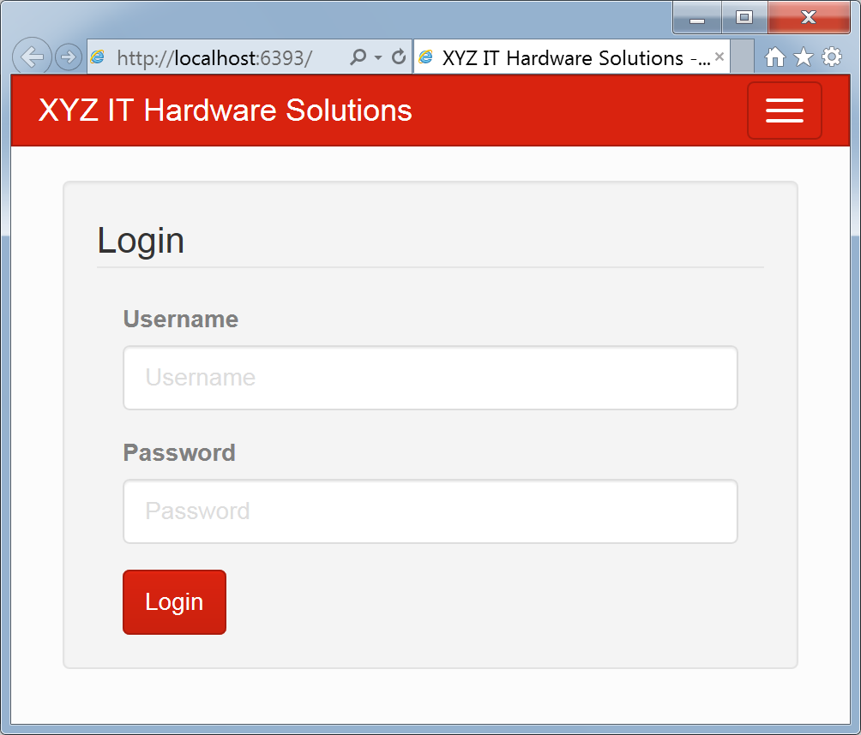

**Administrator Menu**

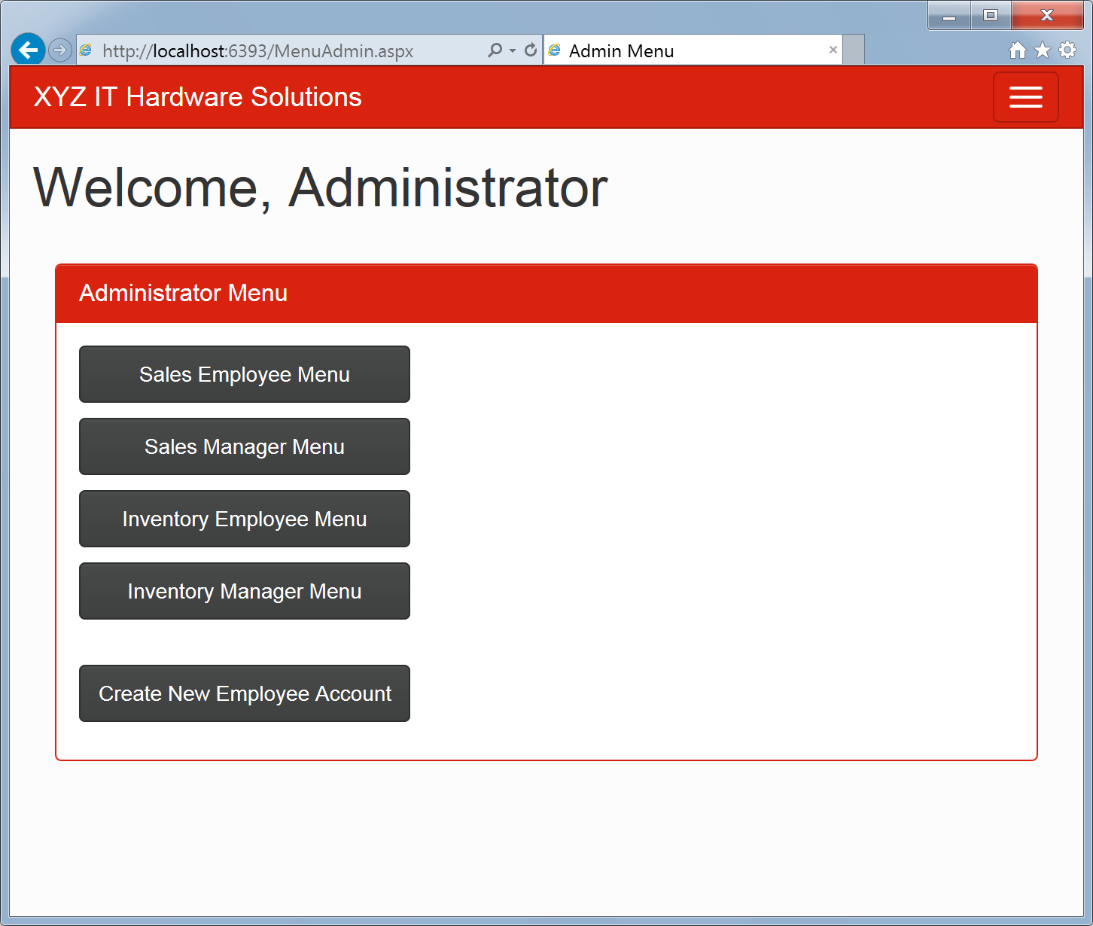

**Sales Employee Menu**

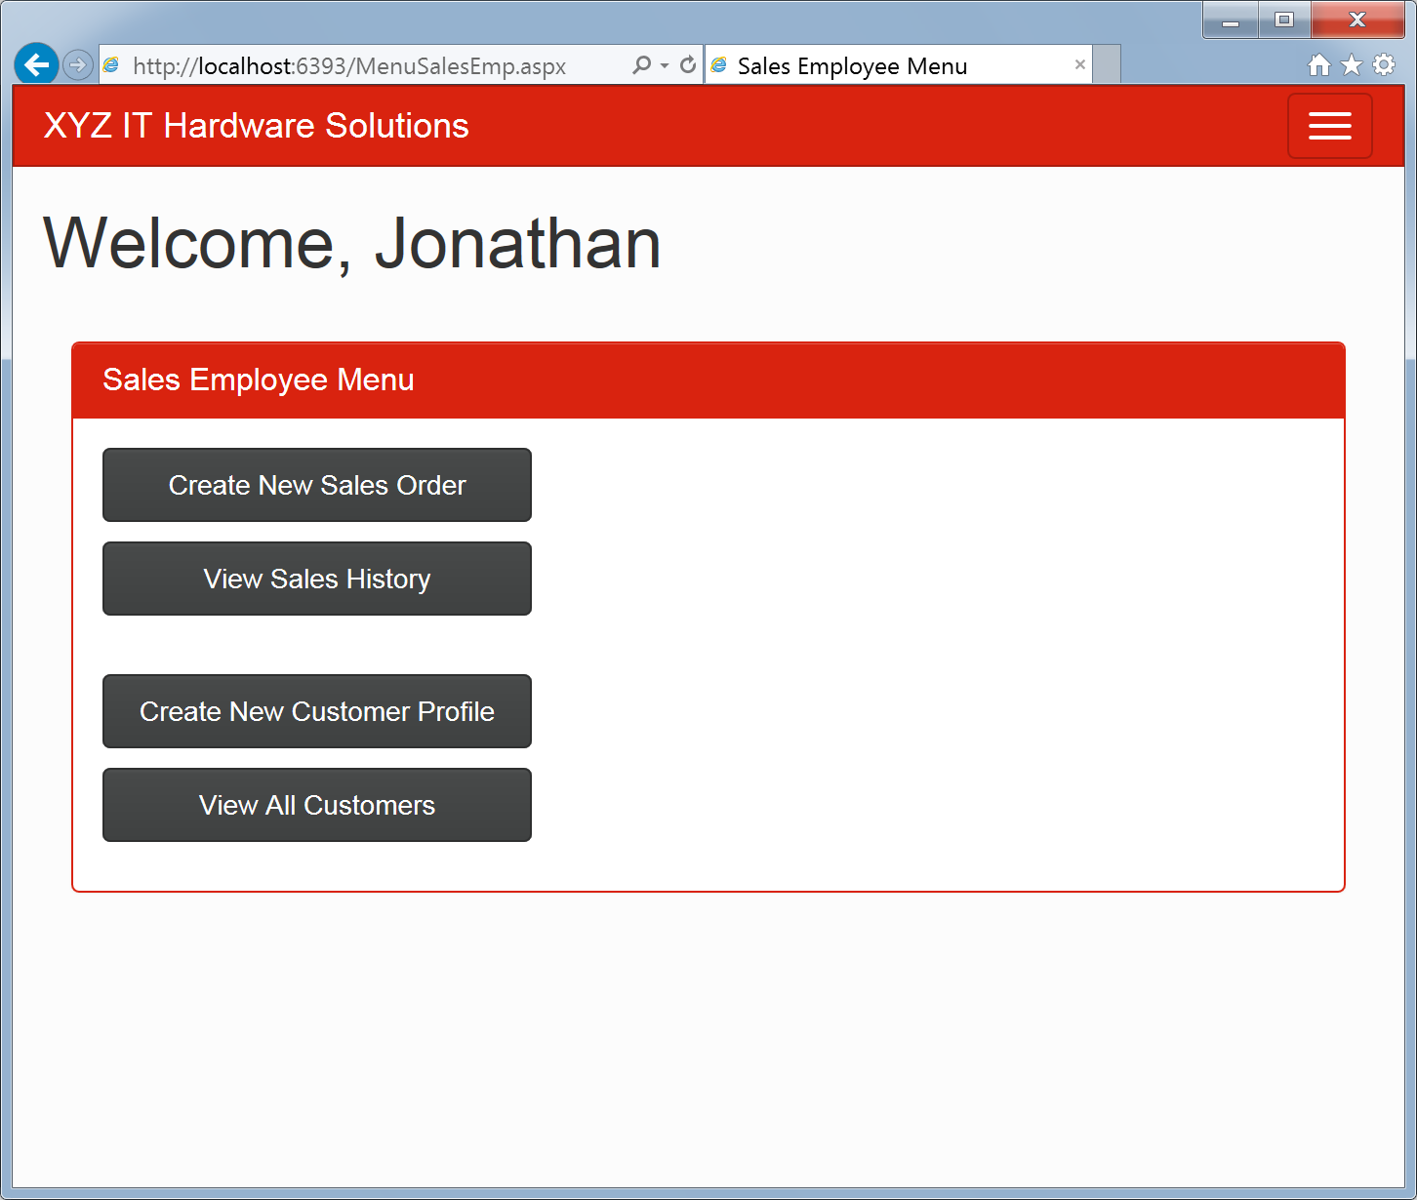

**Sales Employee / Sales Manager New Sales Order Form**

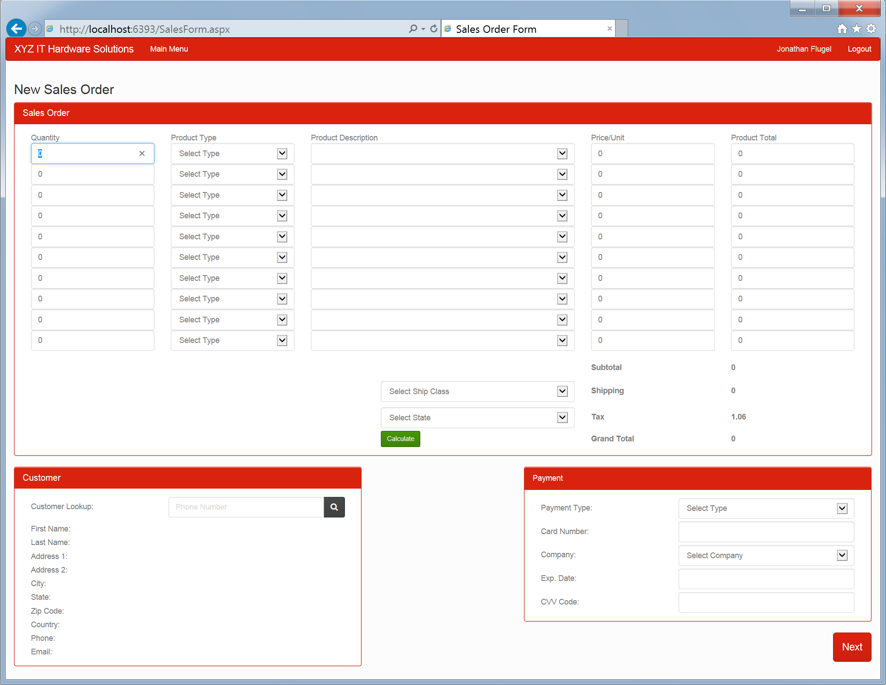

**Sales Employee / Sales Manager Add New Customer Form**

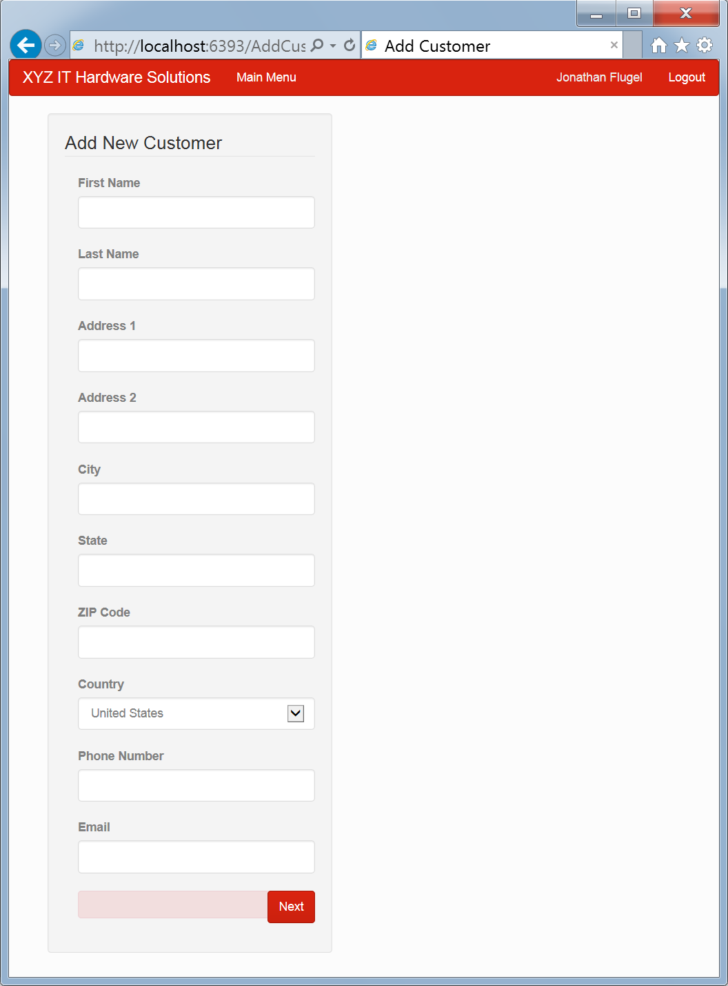

**Sales Employee / Sales Manager Sales History**

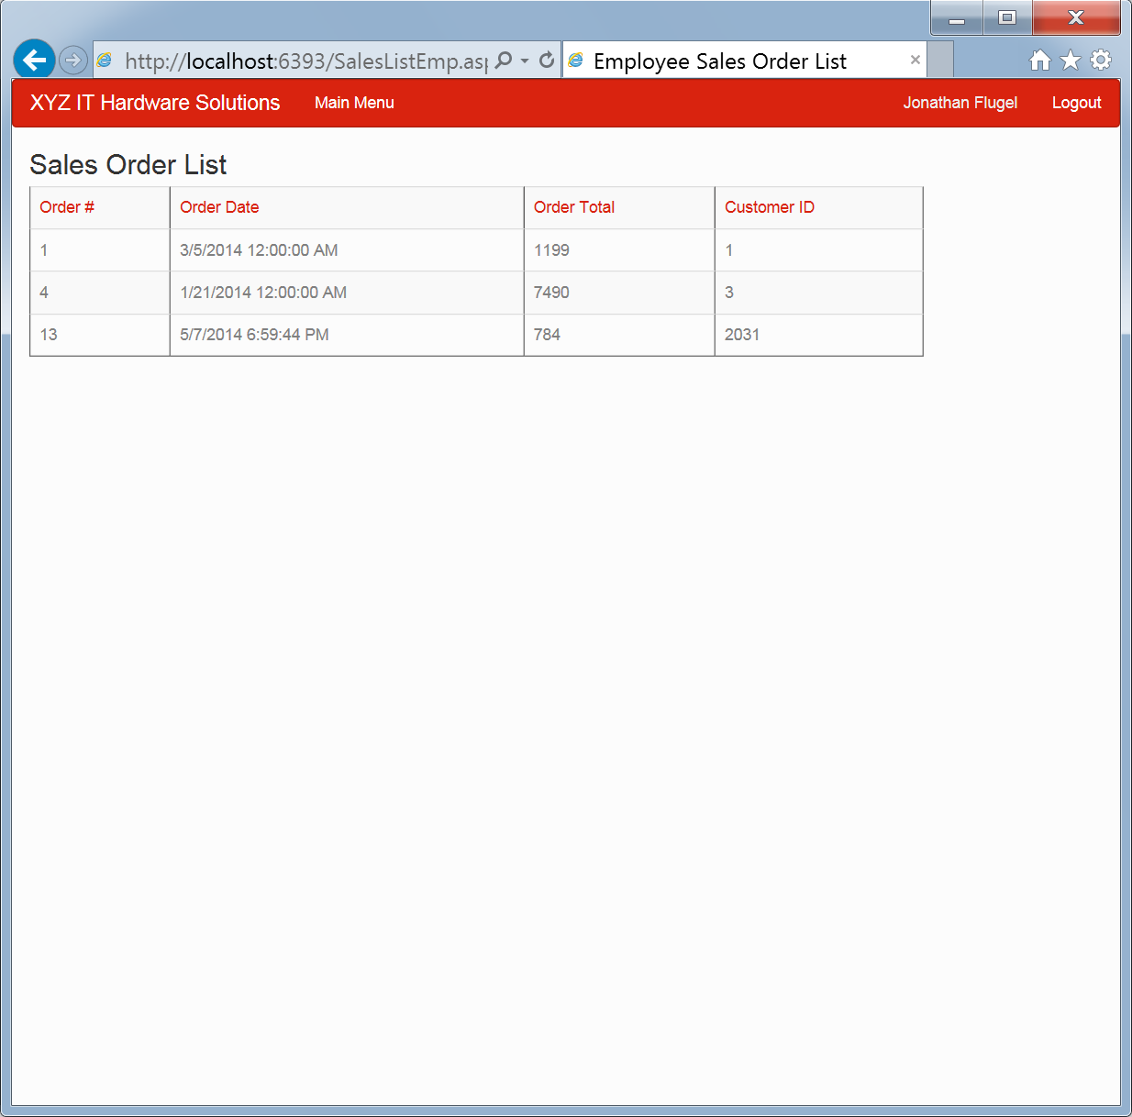

**Sales Employee / Sales Manager Customer List**

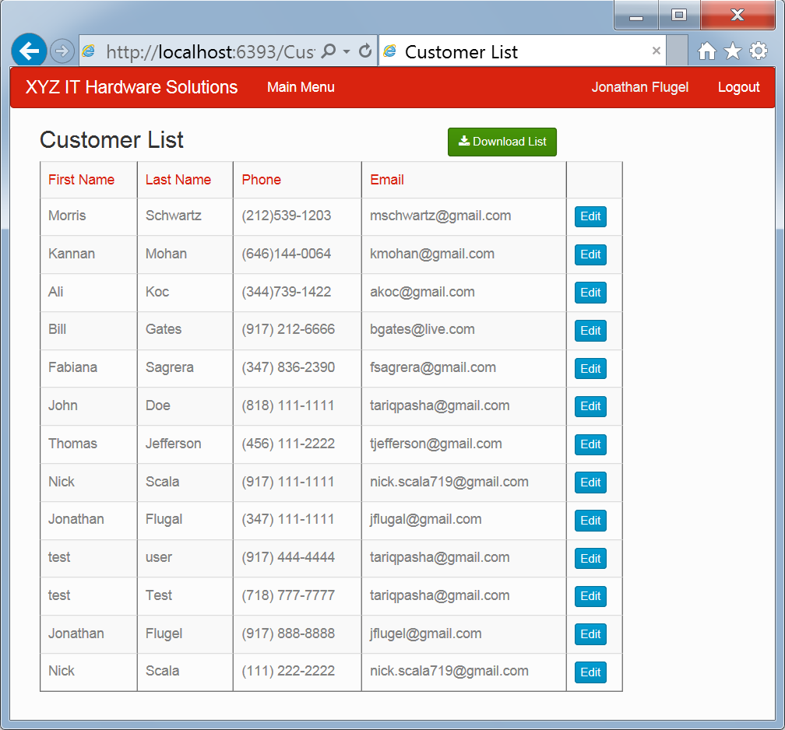

**Sales Manager Menu**

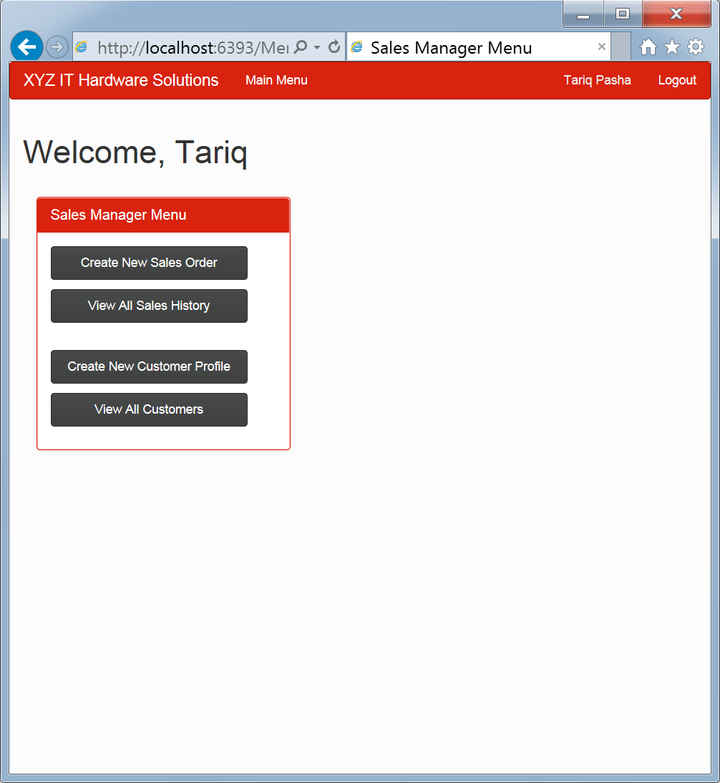

**Sales Manager Order List**

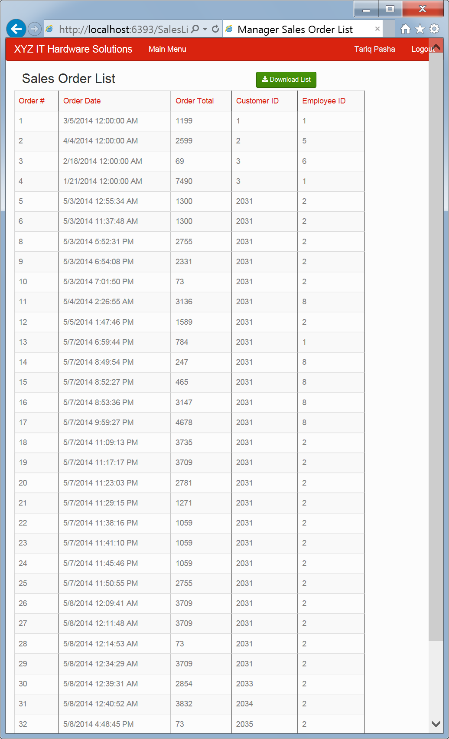

**Inventory Employee / Inventory Manager Menu**

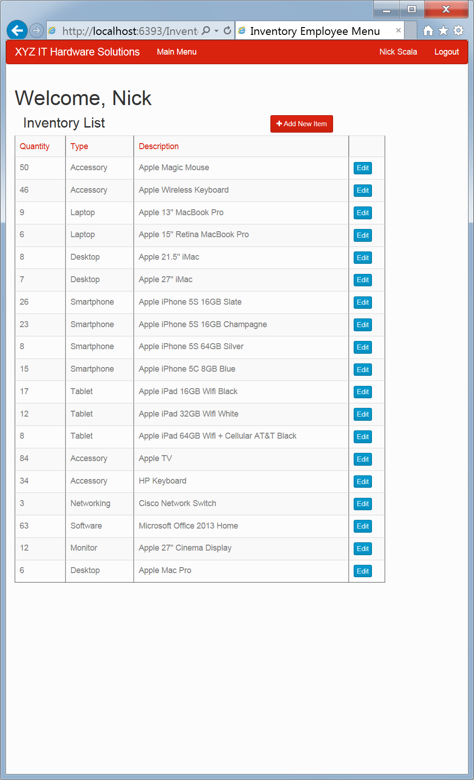

**Inventory Employee Add New Item Form**

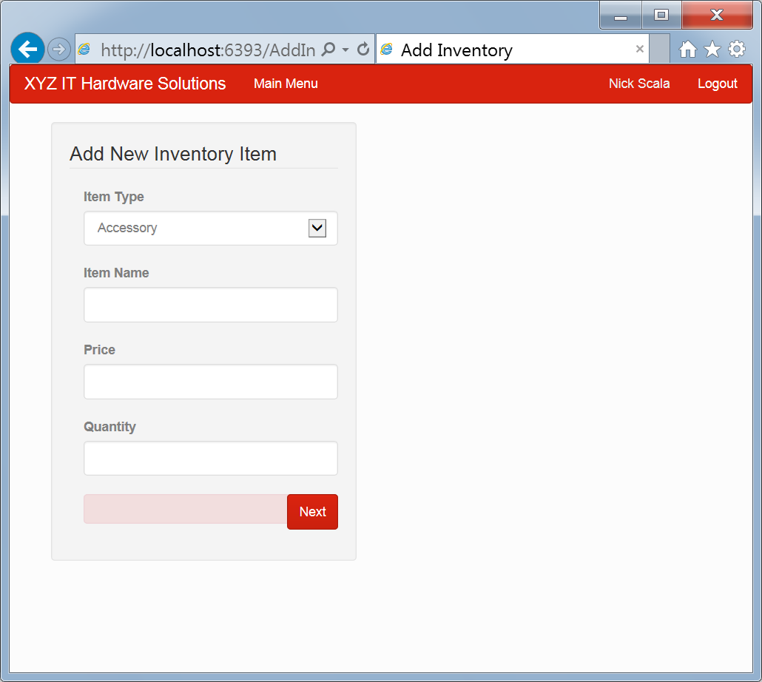

**Inventory Manager Menu**

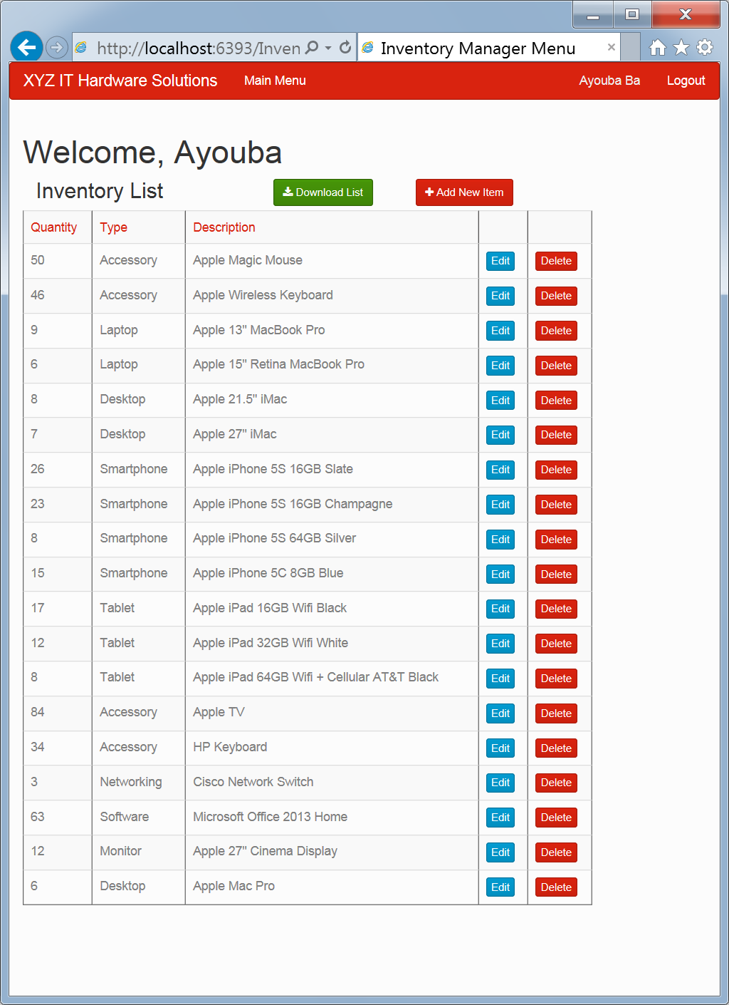

**Inventory Manager Edit Form Enabled**

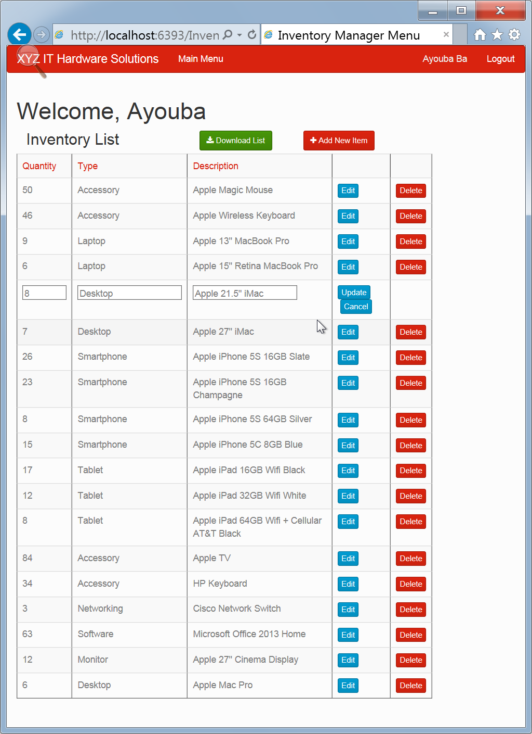

**Access Denied Prompt**

